CHAPTER 1
INTRODUCTION
  - BACKGROUND
Before the development on Large-scale automated detection on misinformation, the identification of misleading false news largely relied on manual fact checking issued by journalists, editors and in depending verification organizations. Where traditional process involves reviewing claims, validating sources and cross checking with trusted resources. Through Digital Platforms like X, Reddit, Instagram where the volume of user-generated content increased mainly, enabling the data to be disseminated within seconds globally. Every minute, Millions of social media users publish posts which contains text, images, posts with their opinions on ongoing events. These posts frequently include multimedia content that could be altered and taken out of context. Because of this, news content is no longer restricted to false textual assertions instead, it frequently blends on text narratives combined with visuals that bolster the information’s veracity.
Text -based methods were the main focus on early research of false news identification later this upgraded as multimodal data like images, videos, and audio also these techniques usually merge as using traditional approaches like Support Vector machines (SVM), Naïve Bayes, or Logistic regression supporting lexical patterns features and statical representations like Bag-of -Words and TF-IDF. These methods produced helpful baseline results, but they frequently had trouble capturing deeper contextual meaning where these methods capture and recognize a limited capacity of intricate patterns of misinformation where their performance was enhanced by deep learning models like Recurrent Neural Networks (RNN) and LSTM which allowed models capture the contextual linkages and sequence dependencies within textual input. Natural Language understanding has evolved dramatically in recent years thanks to transformer- based systems like BERT, RoBERTa and Sentence-BERT. By Examining words connection to their surroundings environment these models are able to acquire contextual representations of the language, which enables them to attain state-of-art performance in number of NLP tasks. Because the absence of external knowledge verification the models are trained very much on well labelled datasets may perform well on previously seen models but often lacks on struggle when they encounter the new claims that require real-world validation proof we know how the output generated to differ what is fake or Real but we can’t able to configure on what basis of credibility of information we always lacks the proof when the algorithm works out well then it may generate the best output but it lacks in verifying factual correctness verifying the credibility frequently involves comparing claims against the external evidence sources without this incorporating evidence, automated systems may rely Soley on learned patterns rather than factual verification.
Inspired by these difficulties, this study suggests the improvement on fake news credibility in contacting sources and maintaining the algorithm influence more strongly and firmly. An Evidence-based multimodal False news detection that combines the level of Text and Image as semantic and visual embeddings into a single architecture. Use of Sentence-BERT embeddings are initially used by the textual assertions. A CLIP-based encoder is used to analyse the visual data related to each claim in order to access the semantic relationship between a related image and its textual claim. Using SBERT and FAISS Vector search over external database, an external evidence mechanism of retrieving the confirmation of the claim. A natural Language Inference (NLI) model based on BART-Large-MNLI model is used to access recovered documents in order to ascertain if the evidence supports or refutes the assertion. Later these multimodal signals which are obtained from this textual and visual semantic and consistency throughout analysis based on evidence verification then is integrated through a feature fusion and classified through using LightGBM ML Model.

  - MOTIVATION
The Inspiration on this project derives from the raising complexity and influence on fake news in contemporary digital environments. Unlike This Traditional misinformation, Modern Fake News often leads to combination of misleading textual claims with manipulated and irrelevant images associated with that and some times it become very difficult to analyse and takes more time to came to know that the image and the headline and information under the news article is different and separate and often creates havoc and confusion to the people and if it is trending topics that make crazy viral news and this causes suffering and difficult to identify. Moreover the current systems detect the news Fake or real but mainly suffers from number of important limitations many models do not consider image context because it is difficult to check only image related content without any claim and this images really target the audiences in deriving the fake updates and other multimodal approaches may consider this but their correlations of claims are not fact checking it’s based on their algorithms where this deep learning models work as black box systems provide predictions without any clear explanations which lowers trust on users and used for limited practice.
All these models may trained well but often struggle to be in its limitations on real world applications to solve this real-world problem there must be a change adding to the most modern problems in order to find it and analyse and what models and this modern technology may helpful to solve this problem.
This Project is Motivated by the need of the solution to develop a robust, efficient and explainable evidence-based fake news detection system that:
- Combining Textual and Visual both to form a proper evidence-based claim on both for its necessity.
- Verifies claims through external knowledge and produces interpretable results with those evidence

  - SCOPE OF THE PROJECT
The Scope of this Project Focuses on updating the design that is already made and reuse that in order to evaluates the real-world issues on that topic which is related that is Fake news where the implementation on Evidence-based multimodal approach that strengthens the system on capturing the factual resources with evidence related that can be found in real time. It has an Evidence Retrieval Mechanism approach using Retrieval - Augmented Generation and Explainable LLM used for Explainability and Reasoning the evidence and later helpful for images also mostly text related papers are provided without any Multimodal approach where to use the RAG the most important thing is to address and find the claim that is related to an topic, object like video, audio and images mainly where the system able to produce the related information using the Transformer Models like SBERT and NLI and CLIP encoder to obtain the various semantic and visual readings from data to use it to derive from external databases like Wikipedia database corpus which is huge bundles of Databases that are downloaded and it works well with real-world inputs and well known structured datasets like FakeReddit dataset which are used in this project main and suitable for academic and research purposes.
    - Limitations:
The system heavily depends on availability and quality on External sources and computational constraints and limits large scale data with dataset image URL problems and LLM Reasoning.

CHAPTER 2
PROJECT DESCRIPTION AND GOALS

  - LITERATURE REVIEW

    - Traditional Text-only Fake News detection
Early Studies for the detection on the false news often mostly used in textual analysis with the traditional ML Methods where numerous researchers assessed performance based on these conventional methods used such as Random Forests, SVM, Logistic Regression and Naïve bayes used with TF-IDF inclusions manually created linguistic characteristics. Benaouda et al. (2024) observed that while Convolutional neural networks can work better than traditional methods earlier as mentioned on some datasets, although both these methods are still supervised and restricted to certain text data, according to comparative evaluations. Similarly, Coban and Bakal (2025) reported comparable findings in NLP-driven false news detection on investigating the usage of TF-IDF and Bag of words featuring with standard classifiers, reaching on competitive performance and being sensitive on dataset-specific patterns and on feature engineering decisions.
    - Deep Learning Techniques used on Fake news detection
Similar Investigations which are explored under Lightweight ML pipelines combining TF-IDF representations with Linear tree-based classifiers highlighting the computations efficiency with the ease of deployment as discussed by Gupta et al. (2022). As Deep Learning Progressed, hybrid architectures that combined sequential models are contextual embeddings were developed to enhance the semantic compression of news content. In Particular, Alghamdi at al. (2022) proposed BERT-CNN-BiLSTM. By capturing temporal and contextual dependencies within the text, architectures showed enhanced classification performance.
    - Multimodal Fake news Detection approaches
Recent research has increasingly concentrated more on multimodal fake news detection modelling both text and visual data in order to overcome the challenges came in text-only approaches. Multimodal frameworks actually design by combining CNN-based textual encoders and BERT-based by capturing the cross-model signals, image extractors. Reddy et al. (2025) demonstrated to enhance the performance when it is compared to unimodal baselines.
In order to get more accurately model correlations between the text and images. Additionaly, Geng (2025) explored and investigated with multimodal interaction using unsupervised feature fusion techniques. Further studies take more exploration on using this unsupervised feature fusion technique to model completely and effectively.
    - Semi-supervised and CLIP-based Oriented Detection
Numerous studies have looked into this semi supervised learning techniques to take advantage of vast amounts of unlabelled content because labelled fake news data is scarce. To propagate this similarity graphs are created using this textual embeddings, graph-based semi supervised frameworks have been proposed by Guacho et al. (2018) that shows the performance on detection which can be accomplished with smaller number of labelled samples. Mansouri at al. (2020) Further extended to better utilize unlabelled data to subsequent studies expanded on this approach by using CNN in semi supervised learning environments.
To detect fake news, recent research directly modelled using image-text alignment using CLIP-based representations. Zhou et al. (2022) demonstrated by calculating similarity scores, CLIP-Based frameworks showed efficacy in detecting inconsistencies between textual and visual content between modalities.
In addition, Benamira et al. (2019) explored to spread credibility labels throughout the social or content-based graphs, more recent research combining semi-supervised learning and graph neural networks, demonstrating enhanced robustness under minimal supervision.
  - RESEARCH GAP
Although Significant progress been made on fake news area projects there are several critical limitations still exist in the current approaches:
- The main Problem on Existing paper approaches are that those approaches totally rely on textual content and the more focus on text data rather than visual information which often plays a crucial role in spreading false information on social media.
- These Multimodal approaches are mainly concerned with learning correlations between text and images content but they do not check on factual correctness by any external databases.
- Existing approaches rarely integrate on factual and external resources such as encyclopaedic databases or fact-checking repositories mainly in order to support the claims present on social media.
- This Deep learning concepts and multimodal approaches mostly work as black-box classifiers, capable of providing predictions without any proper explanations or justifications that can be understand by users.
- Large language models-based systems only enhance the reasoning here with its capability but most of the times this are very much prone to hallucinations when we used without any stretchered retrieval and evidence grounding mechanisms

  - OBJECTIVES
- To Develop a Multimodal Fake news detection system that analysis both text and visual data to identify their inconsistency between text and images in social media posts.
- Incorporate an Evidence-based verification system that helps retrieving and supporting data from a usage of external Knowledgeably sources collecting and evaluating using credibility on claims with NLI while enabling LLM based reasoning for getting predictions and Explainability on new inputs.
- Changing Noticeable problems on fixing errors and adaptable dataset usage and using both labelled and unlabelled dataset on training and testing on upon validation prescribing the confidence level using LightGBM as Classifier that divides the problem and expects that to provide in predicting the output with the help of SBERT and CLIP based pre models that are used as transformer models and classifying into RAG system.
- Later computing that same CLIP score and Evidence consistency score that quantifiably reflects factual alignment between a claim and external information.
- Fuse Multimodal features, visual and text features with their consistency scores and evidence score unified into one major feature fusion ready for representing the classification majorly.
- Developing a Supervised classification model capable of distinguishing between the binary and multiple classification that helps accurately detecting fake and real news all along with their confidence scores.
- Overall, This Framework provides interpretable predictions by supporting and all users understanding the reasoning behind Fake and Real decisions based on claim.

  - PROBLEM STATEMENT
The way we share news online has changed everything, but it’s also made it way too easy for fake news to go viral. Today misinformation is not just a lie in a text post but often a combination of misleading words and edited or out-of-context photos to trick us. This is a big problem as it destroys public trust and can even lead to chaos in real life. Most of the tools we have today are not enough to stop it. Some just look at the words and ignore the pictures. And others just look for patterns but don't actually check if the facts are true. Even the latest AI models sometimes “hallucinate,” making up their own facts instead of hunting down real evidence.
Another big problem is that most detection systems are like a “black box” - they tell you something is fake but never explain “Why”. This makes them difficult to work with for people like journalists or government officials who need to see the proof. Fake news is always changing, and we don’t have enough labelled data to build perfect systems. We need a new approach. The project proposes a new and smarter system that takes into account both text and images. It doesn’t just guess, it actually goes out and finds real world evidence and explains its reasoning in a way that humans can understand. The goal is to make social media safer and more honest by providing a tool that is reliable, clear and ready.
Fake news spreads easily on social media because misleading stories are combined with edited pictures. For example, someone might upload a real picture of a natural disaster, but then claim that it is happening now in another city to incite panic. “Current AI tools often miss this because they might look at the text but ignore the picture, or they might flag it as “fake” without explaining why. This project builds a system that acts as a digital detective; it would see a photo, find the original source online and tell you that it is actually from five years ago. By giving this kind of evidence, the system helps people see exactly how they are being misled.
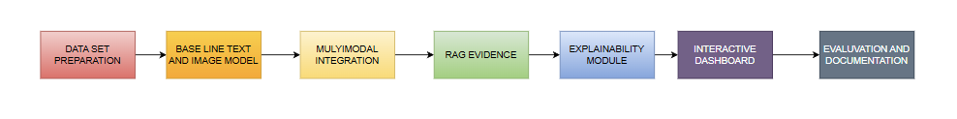
  - PROJECT PLAN
Figure 2.5: Flow Chart of Project Execution
The main thing on what this system focus on instead of preparing an Traditional approaches that totally rely only on text data and algorithms it also add the multimodal approach, detecting the consistency and alignment between the text and its image associated with and both independently by proposing an evidence-guided multimodal framework on Multimodal information of news ensuring not only finding the News is True or Fake but also ensuring that why this answer particularly is been True or not by finding the external sources connected to that news to verify and then bring back the solution of informing why the system performed and on what basis as a proof for this factual information and defining both textual and visual content to go through this retrieved evidence system and later help the system to grow on such for any new news that Large language model helps so that it can bring the new derived reasoning on performance of the Machine learning Classification Model we used and helping to design an Proper RAG which has capability of working and storing external sources with FAISS Search and then verifying its credibility of the Claim is received with NLI model to access this documents and find the external evidence on the dataset.
We have used and to get the evidence score as proof and with Classification training to generate the accuracy of the working Model which may look like simple but when this model brings the output the LLM inference Layer helps the RAG system and the classifier to use this both in order to generate an perfect Explainability feature with the new inputs and new claim where LLM reasoning helps on the focusing on generating output which is accessed on External Knowledgeable sources from RAG system and later verifying using its API as addition on working with Classifier and helps to generate the human readable explanations and later explains its purpose of influencing the classification decision and explaining the reason behind this prediction and also giving the evidence using verified claims and also API modules.
CHAPTER 3
TECHNICAL SPECIFICATION

  - REQUIREMENTS
The Project includes a lot of Dimensionality on providing what the system does and how well the system works well where that can be divided into two categorical requirements:
    - Functional Requirements
- The system is designed to consume multimodal input, whereby users can provide textual claims with associated visual content for analysis.
- It should capture the intent of the claim through contextual embedding techniques, transforming raw textual data into meaningful semantic representations.
- The framework is expected to judge the consistency between textual and visual modalities by computing alignment scores that measure semantic consistency between them.
- We require an evidence retrieval mechanism that can query external knowledge sources to retrieve relevant supporting information for the context.
- The system should verify the factual consistency by examining the correlation between the claim and the retrieved evidence.
- It has to combine multimodal and evidence-based features into a single representation for decision making.
- The system should generate a final judgement of the credibility of the input, with evidence to back the judgement.
- It must produce Interpretable explanations that can justify prediction under a human-understandable manner.

    - Non-Functional Requirements
- We expect that a combination of multimodal and evidence-based signals will provide a high level of predictive reliability of the system.
- It should have good computational performance, i.e. it should be able to handle moderately large datasets within a reasonable time.
- The design should be scalable, such that it can be extended to real-time or large-scale deployment scenarios.
- The usability is emphasised by a simple and interactive interface which makes it easier for users to interpret the results and supporting evidence.
- The system should be transparent, providing clear explanations of its predictions, thereby increasing user confidence.
- It should be portable to standard computing environments with optional support for GPU acceleration for improved performance.
- It should be robust to handle noisy, incomplete or ambiguous inputs without significant loss of performance.

  - FEASIBILITY STUDY
    - Technical Feasibility
The proposed system is technically feasible to implement as it relies on existing, well-supported machine learning frameworks and pretrained models. The approach does not start from scratch but uses existing components such as Sentence-BERT for text understanding, CLIP for visual analysis, and transformer-based models for inference, which makes the development process easier. The system is computationally manageable while providing good performance, thanks to the use of FAISS for efficient retrieval and LightGBM for classification. In addition, the whole pipeline can run on environments like Google Colab with optional GPU support for faster processing. This makes the system accessible and feasible within common academic resources without special infrastructure.
    - Social Feasibility
The project is a relevant and growing problem in society: how to properly identify false social media posts. With so much misinformation online – especially in audio and visual formats combined – it is very difficult for a user to determine what content is legitimate versus what is false. This project helps solve that issue and includes not only a way to identify potentially false information, but will also provide the evidence and rationale for its decision. The project will make the system more relevant in the real-world by allowing users to see the rationales behind each prediction. By providing more support for identifying trustworthy information, the project may help to improve digital literacy and responsible communication.
  - SYSTEM SPECIFICATION
    - Hardware Specification
This design idea implemented actually does not required any external hardware devices or components apart from system computer but the implementation is carried on general purpose computing platforms like cloud-based environments. Where the system provides optional GPU acceleration to support efficient processing on huge models like transformer-based models and CLIP pre trained models where the GPU advantages huge time executing in Colab by reducing computation time during model inference and embedding and makes accessible for academic and research purposes.

    - Software Specification
- PyTorch is the dedicated backend for running deep learning models like CLIP and transformer-based elements in a computationally efficient manner.
- HuggingFace Transformers (Sentence-BERT, BART-MNLI) enable contextual sentence-to-text embeddings generation and natural language inference for evidence validation purposes.
- CLIP (Contrastive Language-Image Pre-training) enables multimodal analysis by quantifying the similarity of textual assertions with respective photo.
- FAISS (Facebook AI Similarity Search) provides the means to create efficient vector indexes and rapidly retrieve evidence from external knowledge-base sources.
- LightGBM is the final classifier that learns the relationship between the multi-modal signals and assigns a value of false or true to a news story.
- Scikit-learn includes features for data processing, normalizing of features, splitting dataset, and evaluating results (accuracy and F1-score).
- Streamlit provides an interactive interface for testing out the system using new product inputs and visualizing predictions with evidence and rationale.
- Google Colab is the working environment where development and execution occur, as well as cloud-based services and optional GPU capabilities.
  - USECASE DIAGRAM

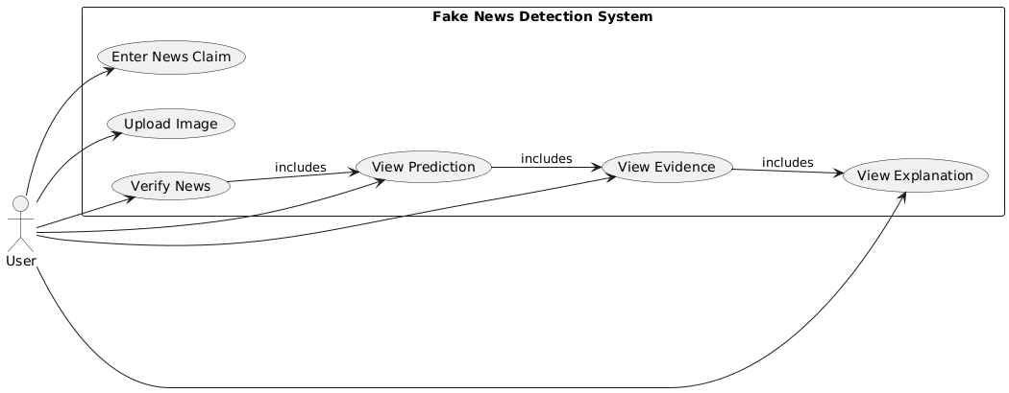
Figure 3.4: Use case Diagram of the Project

- The use case diagram depicts how the user and the fake news detection system interact with input being provided by the end user in the form of text and optionally an image.
- The user is able to process their request via the system through the Verify News function which consists of a prediction stage followed by retrieving evidence and producing an explanation.
- The system will return the output prediction (fake or real) plus evidence supporting that decision and an explanation as well, to provide both usability and interpretability of the system.
  - DATAFLOW DIAGRAM

- The data flow diagram depicts the process flow of the input data (text and image) through several stages: Feature extraction via SBERT while performing feature extraction via CLIP, Evidence retrieval through RAG, and Feature Fusion.
- The system will retrieve supportive evidence from an external knowledge base that it will then use to combine with extracted features for improved decision-making on evidence by applying those features to the item in question.
- The final output will be generated through a LightGBM classifier and the LLM explainability layer to provide the user with a prediction and supportive evidence and/or reasoning.

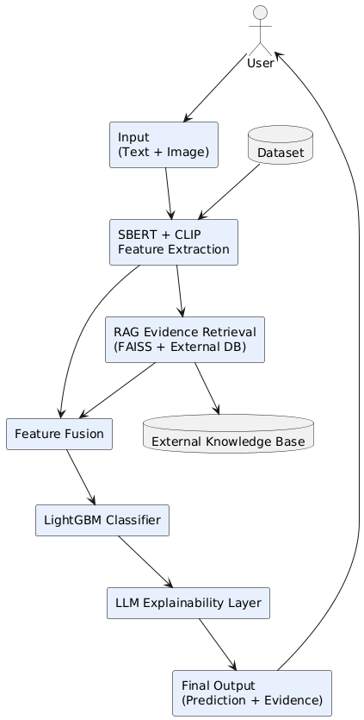
Figure 3.5: Data Flow Diagram of the Project
CHAPTER 4
SYSTEM DESIGN

4.1 SYSTEM ARCHITECTURE
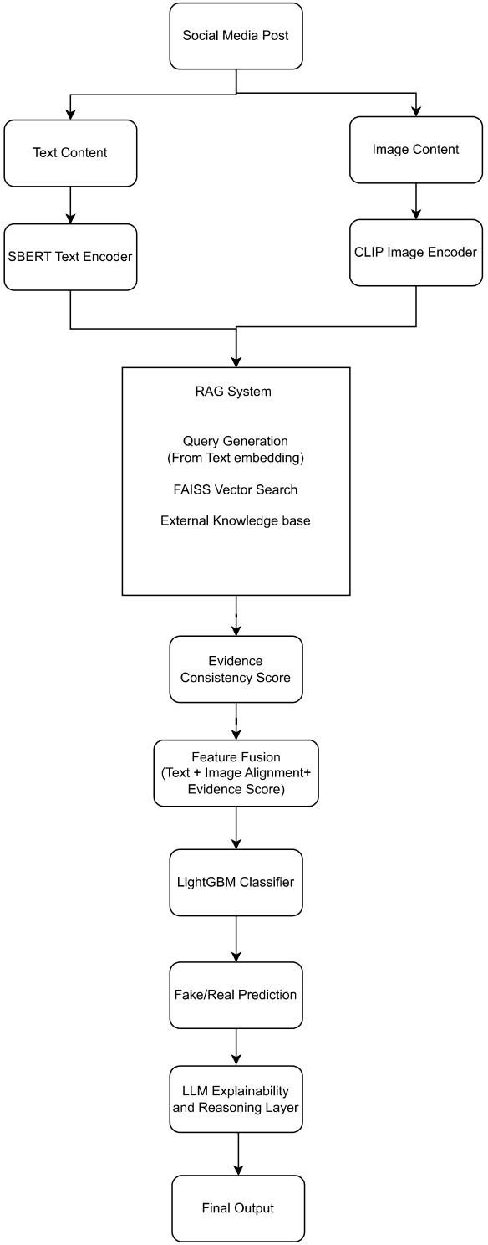
Figure 4.1: Proposed Architecture on Multimodal Fake News Detection
This proposed architecture is a sequential approach to identifying fake news by assessing three main criteria: a textual analysis, a visual evaluation, and an evidential or logical basis for supporting the statement presented. The example of a social media posting containing text content and an image showing similar information is shown in the figure. The text content is passed through a Sentence-BERT encoder to create dense semantic embeddings (contextual meaning is not captured by simple keywords) of the input. Simultaneously, the image is processed with a CLIP encoder, which takes the visual content and projects it into the same semantic space as the text so that the system can determine if the image provides meaningful support of the statement made. Once both the textual and visual stream have been completed, they converge into the RAG (Retrieval-Augmented Generation) module, where the textual embeddings serve as queries to retrieve relevant information from an external knowledge base using FAISS-based vector search. This places factual grounding into the system by introducing actual evidence from the real world, not learned patterns.
After retrieved evidence is evaluated through the calculation of an evidence consistency score to indicate the extent to which the external evidence supports or contradicts the original claim, the evidenced consistency score, the retrieved text embedding of the evidence, and the image-text alignment score will all be used to create a comprehensive integrated representation of the input during the feature fusion stage. The fused features will be inputted to a LightGBM classifier to learn complex decision boundaries associated with the evidence inputs and to produce a final prediction (fake/real) regarding whether the news is fake or real. Finally, the prediction will be processed by an LLM-based explanation layer, which will provide a human-readable justification based on the retrieved evidence. For example, if an original claim states that a public figure made an alleged controversial statement with an unrelated image, the system will detect the inconsistency between the text and the image and will retrieve factual sources based on the claim (that support or refute it), leading to the most likely prediction of "Fake" along with excerpts of evidence provided and with a clearly articulated explanation of why the classification was made in order to enhance the interpretability of the prediction. This end-to-end design provides a multimodal understanding of a news story/claim along with verifiable reasoning beyond the traditional black-box classification model, thus providing the user with confidence in the accuracy and trust of the system for real-world use cases.

- Textual Semantic Representation: Text content on social media which is the main source of claims is processed first using Sentence-BERT that help to obtain semantic embeddings. It is designed in a way that it can capture the semantic relationships between the words and phrases by encoding these claims into the dense embeddings so that system work effectively in representing the text data.
- Image-Text Consistency analysis: Where we say the text is important as it is used as claim related to text data like image data are also very important to accurately represent its textual claim. So, this proposed framework defines the system with multimodal approach of combined data (Text + Image) correlatedly to incorporates the image and text verification. Generally, the text may be different and the associated image can be an Deep fake AI image that is totally fake so in order to relieve from this problem the visual content is extracted to CLIP image encoder in order to find the similarity between the text and image embedding where to compute whether the image supports the related text content or not to detect the consistency and inconsistency between both through this similarity score.
- Evidence Retrieval using RAG: Next step will be to verify the credibility of our claim here comes the Novelty part of using RAG so that the system can support the information from external sources to require the evidence documents related to dataset where the textual embedding is generated by SBERT is used as Query generation and FAISS Vector Search is used on providing the contextual information searched against an indexed evidence corpus to support the claim.
- Evidence Consistency Evaluation: This step generates an Evidence consistency score by verifying through NLI Model where this particular method represents a level of agreement based on the claim that is provided by RAG with evidence documents where this score helps whether the system is truly getting and generating information aligned to the external resources.
- Feature Fusion with Classification: From the previous models’ results are totally combined here to generate the Final output through combining all data results with evidence as the pipeline moves forward to combining and later on using this feature representation to be passed through LightGBM classifier which learns the data patterns associated with the data posts for predicting the real and fake news. Where this model promotes itself joining the LLM layer which helps the reasoning for making an better inference for explanations and later it is used on new inputs and recent news or old news which is given as new inputs later generated the final outputs by going through all this pipeline with external evidence verification from RAG for evidence grounded explanations to LLM generated human readable explanations explaining all and accessing the new inputs without any inconsistency and can easily accessed this system in dashboard interface used on to increase the quality of work and state of art by improving the reliability of fake news detection which provides evidence and explanations on claim in order to prove its predictions.

4.2 DETAILED DESIGN
4.2.1 Sequence Diagram
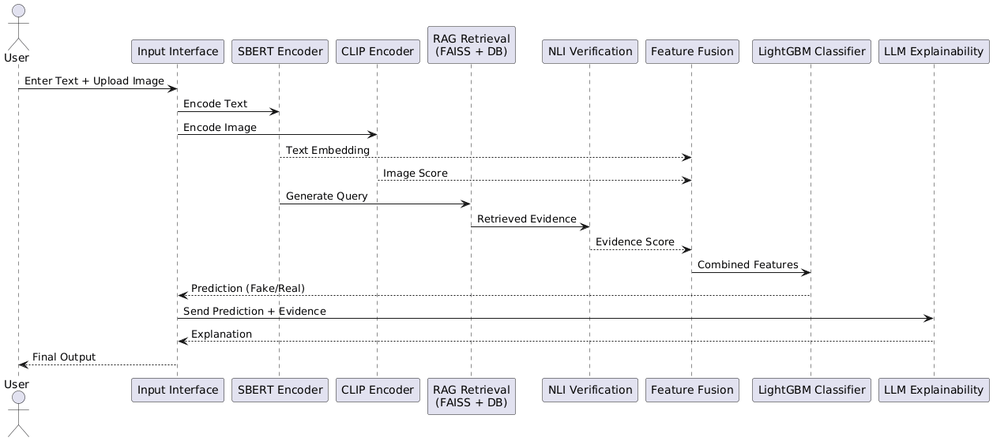
Figure 4.2.1 Sequence Diagram of the Project

- A diagram of how the system's parts work together over time (the sequence diagram) shows the chain of events that occur when a user inputs data into the system across the three modules; encoding, retrieval, and classification.
- It shows how message exchanges occur with each module and how the embedding, evidence, and feature representations are passed from one module to the next until the system predicts an outcome. The last few steps of the sequence diagram show how the system moves become generating a prediction to generating an explanation about that prediction to the user.
4.2.2 Class Diagram
- The class diagram provides an overview of the different types of modules comprising the system. Each class in the class diagram corresponds to a specific functional module of the system (e.g., text encoding, images processing, evidence retrieval, and classification).
- The class diagram also demonstrates how the modules function together logically, e.g. how data flows from input handling, through feature extraction, and finally to prediction and explanation. As such, the system has been designed to utilize a modular design and be easy to scale.

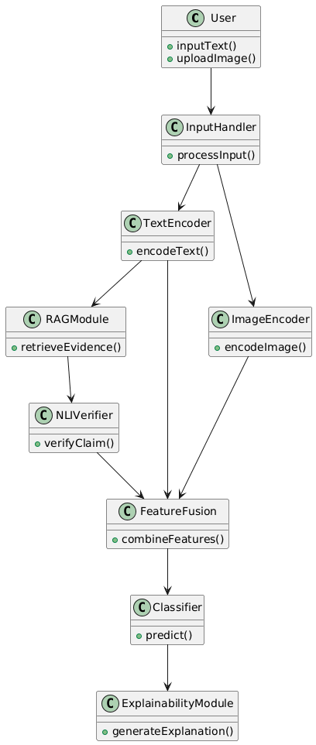
Figure 4.2.2 Class Diagram of the Project
4.2.3 Activity Diagram
- An activity diagram has been provided below to illustrate how the entire system executes from a user input to the completion of the final output after feature extraction, evidence retrieval, classification and finally producing an output based upon the results obtained from the previous actions.
- It demonstrates how the process commenced with user input, progressed through feature extraction, supported by evidence retrieval (to validate evidence from the examples in sections 2.1 and 2.2), classified as either ‘fake’ or ‘real’, and generated an explanation, all while displaying the extent to which all previous processes affect all other future steps in sequence.

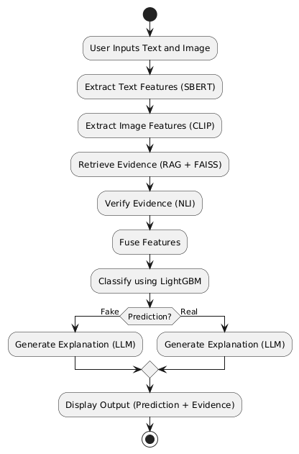
Figure 4.2.3 Activity Diagram of the Project

CHAPTER 5
METHODOLOGY AND TESTING

5.1 MODULE DESCRIPTION
The Module development Stage consists more representations on the models and algorithms that have been used in this project to build the whole framework and pipeline step by step integrating the image-text alignment, evidence retrieval tasking, logical reasoning to produce realisable output predictions.
This Framework is designed as hybrid model development pipeline, where each model contributes specific features and tasks and helps to strengthen the model efficiency and its development and final decision is derived from using supervised learning model followed by an explainable layer completely.
5.1.1 SBERT Text Encoder (Semantic Learning Module)
The first phase in the pipeline involves using Sentence-BERT (SBERT) for extracting semantic representations from text. This type of model transforms input (news) headlines into dense vector embeddings, capturing contextual meaning instead of the frequency of occurring words.
Working Method:
- An input sentence is tokenized, then a transformer-based encoder processes it. The all-mpnet-base-v2 model generates contextual embeddings.
- The output is the fixed-size (768 dimensions) vector representation that captures semantic similarity.
Results of Implementation: Text Embedding Shape: (20000, 768)
Advantages:
- Captures deep semantic meaning of text
- Allows for retrieval of similar items based on semantics (in RAG)
- Decreases reliance on hand-crafted features

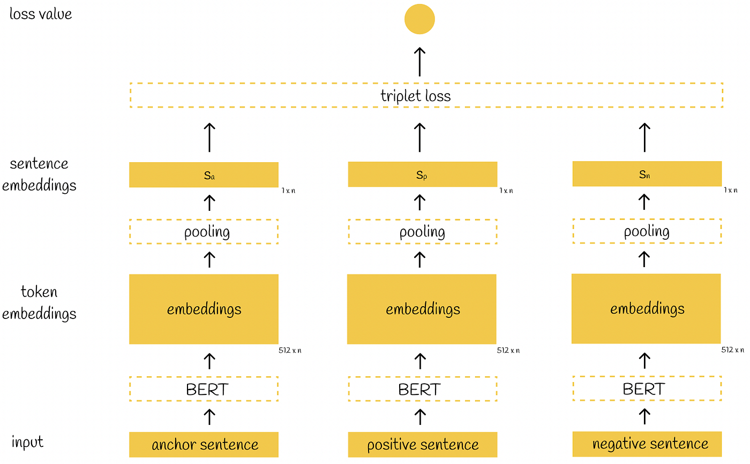
Figure 5.1.1: Sentence-BERT Diagram
5.1.2 CLIP Model (Image-Text Alignment Module)
In order to add visual elements into the system, the CLIP model is used to determine how semantically consistent an image is with a piece of text.
Working Method:
- Images and text are both encoded in to the same embedding space.
- A similarity score is calculated between the image and text representations.
- The higher the CLIP score, the stronger the alignment. Conversely, the lower the score, the more mismatch.
Results of Implementation: CLIP Score Shape: (20000, 1)
Advantages:
- Identifies misleading/unrelated pictures.
- Effectively handles multimodal misinformation.
- No task-specific training required for this model.
5.1.3 RAG + FAISS (Evidence Retrieval Module)
A Retrieval-Augmented Generation (RAG) process was created to confirm assertions by utilizing outside sources. This is accomplished via a FAISS system, which performs rapid similarity searches.
How it works:
- Only factual news stories were used during the creation of the evidence corpus.
- Evidence is indexed in FAISS by using SBERT embeddings.
- For any provided input request, the top k matches are located based upon their vector proximity to each other.
Results from implementing this process:
- Evidence Corpus Size: 12094 documents
- FAISS Index Created successfully
Benefits of this process:
- Prevents circular logic through usage of actual data.
- Allows high-speed retrieval of large amounts of data.
- Provides factual grounding for predictions.
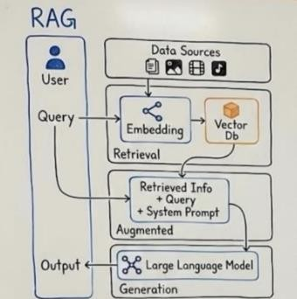
Figure 5.1.3: Conceptual Overview of Retrieval Augmented Generation (RAG) Framework
5.1.4 NLI Verification (Evidence Consistency Module)
After retrieving, the evidence will be run through a Natural Language Inference (NLI) model to verify if the claim has supporting evidence.
How it works:
Each claim/evidence pair goes to a BART-MNLI Model to receive probabilities/weights for Contradicting, Neutral or Supporting.
Consistency score is computed as:
$$Score=P_{contradiction}-P_{entailment}$$
Postive -> Likely false
Negative -> Likely Real
Results from implementing this process: RAG Score Shape = [20000 x 1]
Benefits of this process:
- Provides logical verification of assertions.
- Decreases false positives.
- Provides an easy way to understand the predictions.
5.1.5 Feature Fusion Module
At this step, features from the previously defined modules are combined into a single representation (i.e., one combined feature).
Feature composition:
- SBERT embeddings→ 768 dimensions
- CLIP score → 1 dimension
- RAG-NLI score → 1d dimension
$$X=[Text_{768}+CLIP_{1}+RAG_{1}]=770\text{ dimensions}$$
Combined shape of features = (20000, 770)
Processing steps: Standardize features prior to training using StandardScaler.
5.1.6 LightGBM Classifier (Final Prediction Module)
The fused features are then used to fit a LightGBM classifier for the final prediction.
Mode and function: using gradient boosting, the trees are added together iteratively, based on the errors estimated by the previous trees, yielding a final prediction after performing weighted ensemble learning.
Model Configuration:
- n_estimators=500
- Learning_rate=0.05
- Max_depth=10
- Num_leaves=31
Training Setup:
- Training Set= 16000 samples
- Validation Set = 4000 samples
Performance:
- Validation Accuracy = 90%
- Balanced precision and recall
Key advantages:
- Ability to handle High-dimensional features and mixed feature types
- Feature importance
5.2 TESTING
5.2.1 Testing strategy
Multiple levels of testing were conducted to verify the performance of the various modules as well as the overall system. Each module was verified individually, and then combined to form the complete pipeline.
Realistic social media data sets combining text and images were used in testing. Particular testing scenarios included misleading images, ambiguous information, and partially true statements.
5.2.2 Model Evaluation Testing
The precise effectiveness of predictions in distinguishing between real and fake news were evaluated by way of standard classification metrics and confusion matrix values for the model's True Positive (TP), True Negative (TN), False Positive (FP), and False Negative (FN) classifications.
- Accuracy: The goal of accuracy is to assess the correctness of the model based on the number of accurately classified instances in all predictions; therefore, accuracy is the overall measure used to evaluate the performance of a model with respect to its two classes.
$$\begin{matrix} & \text{Accuracy}=\frac{TP+TN}{TP+TN+FP+FN} & & \text{(1)}\end{matrix}$$
- Precision: Precision measures the reliability of positive predictions; specifically, it quantifies the number of instances that were predicted as "fake" and were actually fake. This is especially helpful in decreasing the number of false alarms.
$$\begin{matrix} & \text{Precision}=\frac{TP}{TP+FP} & & \text{(2)}\end{matrix}$$
- Recall: Recall (or sensitivity) indicates the success of a model's ability to identify all of the positive instances that exist. Recall thus indicates how successfully the model detects non-fake news without having been missed by detecting fake news to a high degree.
$$\begin{matrix} & \text{Recall}=\frac{TP}{TP+FN} & & \text{(3)}\end{matrix}$$
A model that has high recall captures many of the fictitious news stories.
- F1-Score: The F1 Score is defined as the harmonic mean of precision and recall, and it provides a measure of the success of the model for both false positive and false negative values.
$$\begin{matrix} & F1=2×\frac{\text{Precision}×\text{Recall}}{\text{Precision}+\text{Recall}} & & \text{(4)}\end{matrix}$$
- CLIP Image-Text Similarity: The CLIP model maps the textual content and Image content both shared into a shared embedding space. Similarity between the image and textual content is computed using cosine similarity on determining whether the images are relevant to textual claim and aligns with it.
It is defined as:
$$\begin{matrix} & S(I,T)=\frac{f(I)⋅g(T)}{∥f(I)∥ ∥g(T)∥} & & \text{(5)}\end{matrix}$$Where I represent Input Image, T represents Textual Claim, f(I) denotes image embedding and g(T) denotes textual embedding.

- RAG Retrieval Similarity: The retrieved evidence module identifies the most supporting evidence by comparing claim embedding with evidence embeddings stored in FAISS index.
The similarity between vectors is computed using Euclidean distance.
$$\begin{matrix} & d(q,x_{i})=∥q-x_{i}∥^{2} & & \text{(6)}\end{matrix}$$

- LightGBM Prediction Function: Final Classification output is performend using LighGBM model which combines multiple descision trees to go through gradient boosting. The prediction function aggregates the outputs of multiple trees to generate the final probability score.
$$\begin{matrix} & \hat{y}=\sum_{k=1}^{K}{f_{k}}(x) & & \text{(7)}\end{matrix}$$Where fk(x) represents prediction of the kth decision tree and M denotes total number of trees in ensemble.
CHAPTER 6
PROJECT IMPLEMENTATION

6.1 EXPERIMENTAL SETUP
The experiments were conducted so that it can be useful for evaluation when it is been compared with my combined feature fusion so it can be much more bring effectiveness for my proposed method on fake news detection framework and also based on the related works on how they have did the model comparisons so that to compare which each model and choosing their suitable model and related to what ML algorithm works better and suitable to work as classifier with using other pretrained models and efficient on those frameworks.
Table 6.1 – Model Comparisons Results
Model | Accuracy | Precision | Recall | F1
Logistic  Regression | 0.9835 | 0.979747 | 0.978508 | 0.979127
Decision  Tree | 0.9605 | 0.939506 | 0.962073 | 0.950656
Random  Forest | 0.9655 | 0.973753 | 0.938053 | 0.955570
Gradient  Boosting | 0.9815 | 0.987080 | 0.965866 | 0.976358
KNN | 0.7855 | 0.738158 | 0.709229 | 0.723404
SVM | 0.9475 | 0.938619 | 0.927939 | 0.933249
XGBoost | 0.9845 | 0.990956 | 0.969659 | 0.980192
LightGBM | 0.9835 | 0.992208 | 0.965866 | 0.978860
LSTM | 0.976 | 0.9856 | 0.9532 | 0.9691

Tabel 6.1 presents the comparison of various machine learning models and ensemble models trained using extracted multimodal feature representation. So, the evacuated models and these experiments are conducted where the results show the ensemble models are outperforming the traditional models both here based on observations LightGBM is been selected although XGBoost is also recommended LightGBM is slightly effective for high-dimensional tabular features as it will use histogram based gradient framework that handles large feature types and reduces complexity. And it is faster than other ensemble models in training and suitable for large scale datasets and lower memory usage.

6.1.1 Ablation Studies
configuration | Accuracy | Precision | Recall | F1
Text only | 0.7970 | 0.739726 | 0.750948 | 0.745295
Text + CLIP | 0.8020 | 0.749684 | 0.749684 | 0.749684
Text + RAG | 0.9845 | 0.992228 | 0.968394 | 0.980166
Full Model | 0.9835 | 0.990933 | 0.967130 | 0.978887
Table -6.1.1 Ablation Study Results

The analyzation of the proposed Framework is also important as it is conducted on basis of some configurations like Text only, Text with CLIP, Text with RAG like that so that each component can be detect of how much intel we are gathered and also from staring the pipeline is built is in this manner where with each addition of every classification report is generated as progress are been slightly higher as going on where the text only improves classification performance where the multimodal aspects the CLIP and evidence retrieval is fully combined as we see progress is increased properly.
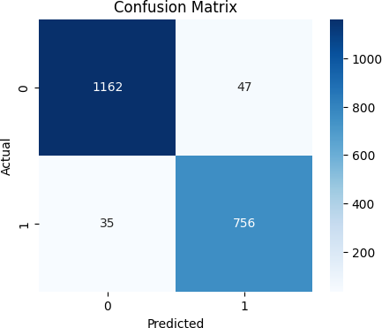
Figure 6.1: Confusion Matrix on Validation dataset based on Comparisons
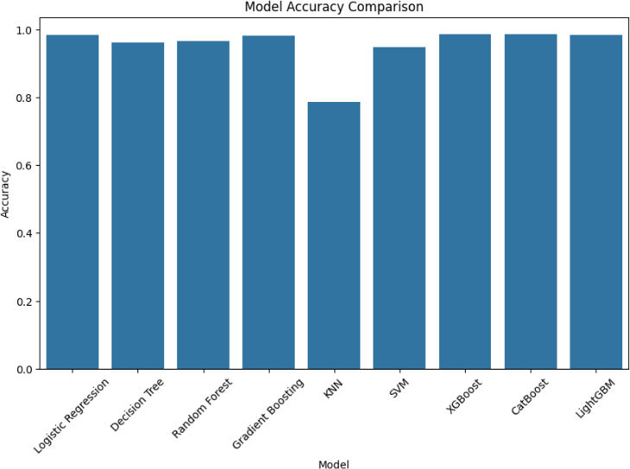
Figure 6.1.1: Model Accuracy Comparison

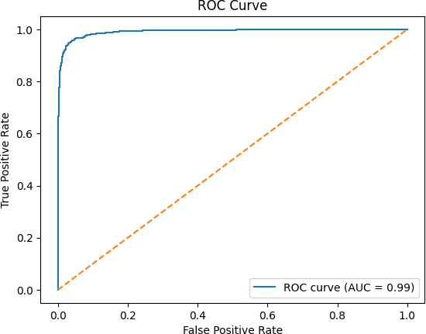
Figure 6.1.2: ROC Curve on validation dataset based on comparisons

6.2 DATASETS WITH DESCRIPTION
Large-scale multimodal datasets have been instrumental in progressing fake news detection research. The Fakeddit dataset offers a comprehensive benchmark with fine-grained fake news labels and visual content for the systematic evaluation of unimodal and multimodal models [Nakamura et al., 2020]. Although the Fakeddit dataset has supported a considerable amount of change in multimodal detection; the baseline models provided do not leverage external evidence retrieval or reasoning techniques or provide explainability; therefore, there is an opportunity for additional methods of improvement.
This Proposed Architecture went under the training and evaluation using the Main dataset Fakeeddit Dataset containing multimodal data where the reddit posts are attached text associated with image where every instance the dataset indicates three primary components: a textual headline (Clean title), a corresponding URL of images (image URL) and a binary classification label(2_way_label) consists of the real (0) and fake (1) data. This provides an effective platform of using in a multimodal approach because it allows the visual content and textual semantic analysis.
In this system for usage of dataset on training is been selected 20,000 samples randomly as an subset that provides computational efficiency because it will take more time and more storage and GPU to do operations like CLIP models and FAISS vector search mainly used on this data because of some broken URL’s the image gets blocked and it becomes very difficult to use more than 30,000 so here we selected this using a fixed random seed to ensure reproducibility.From the selected dataset 12,094 real news articles and using of Wikipedia FAISS corpus of 20,000 articles since the primary verified news are collected from dataset but for external resources for new inputs using the external knowledge repositories for fact check sites as Wikipedia to support the evidence-guided verification with LLM reasoning.

CHAPTER 7
RESULTS AND DISCUSSION

  - RESULTS

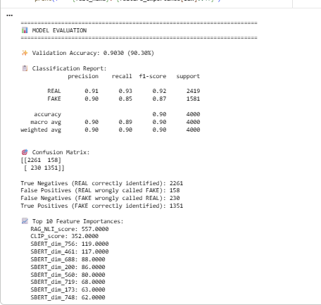
Figure 7.1: Classification Report showing Evaluation Metrics

This Evaluation Results shows on that model has overall achieved a validation accuracy of 90.30% on validation dataset. Where for the Real samples of news category achieved 0.91 precision and recall of 0.93, while then fake samples news category has achieved 0.90 precision and recall of 0.85 overall resulting in weighted F1-score of 0.90 approximately. These results determine and evaluate the multimodal feature fusion approach made effectively to achieve the gaps of existing work by capturing semantic variations on text and visual and embeddings on evidence guided signals that contribute effectively improving misinformation detection.
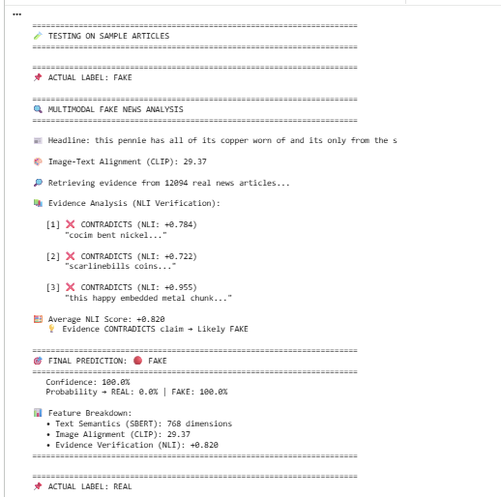
Figure 7.1.1 NLI Validation of retrieval evidence comparing with external Wikipedia Database (Text only)
  - Final Results
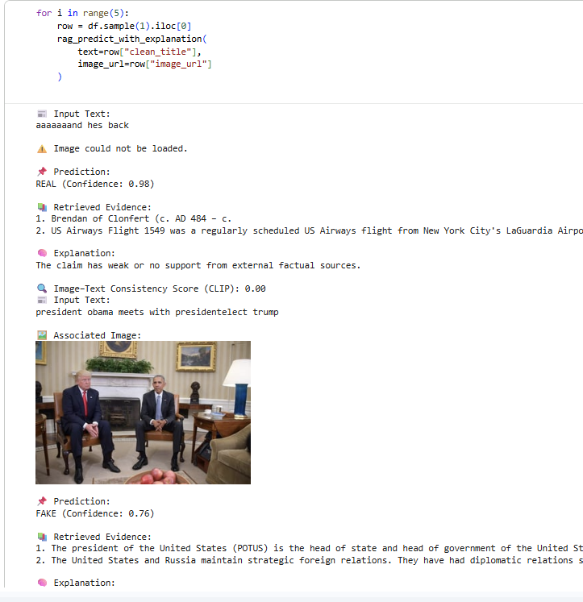
Figure 7.2: Evidence Retrieval output without LLM inclusion reasoning example from Dataset

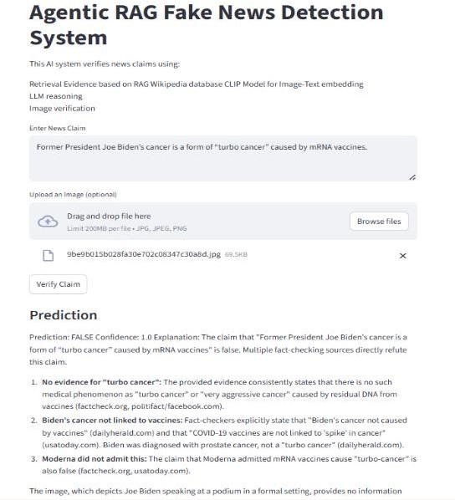
Figure 7.2.1: Final output using Retrieval Evidence on RAG Wikipedia database and LLM API Prediction on Fake news with Evidence

Figure 7.2.2: Final output using Retrieval Evidence on RAG Wikipedia database and LLM API Prediction on Real news with Evidence
CHAPTER 8
CONCLUSION AND FUTURE ENHANCEMENTS
8.1 CONCLUSION
The System combines Sentence-BERT embeddings, CLIP image-text alignment and RAG based evidence system working with LightGBM Classifier and LLM Reasoning access for Final prediction all this depicts the uniqueness on its own of using this models and showing them how this will support the fake news detection systems turning from ordinary to upgrading and improving the system with the evidence verification and multimodal approach where the proposed model achieves validation accuracy of 90.30% showing how well it improved compared to traditional methods. Supporting practical new instance and framework of explainable actions proving for giving a practical and scalable solution for improving misinformation detection on social media.
8.2 FUTURE ENHANCEMENTS
Extension on framework to multilingual format enabling system to analyse fake news across different languages and global social media platforms. Proposed system can be driven to agentic architecture in future where multiple agents equally collaborate on performing tasks and specialized agents can follow dynamic approaches like automated and adaptability in improving reliability in real time monitoring systems.
Furthermore, the proposed framework can be improved by taking into account the time context of news events, and therefore help identify outdated or recontextualised content that has been reused to spread disinformation. One avenue for extensions to this framework is to include a user credibility and source reliability aspect, in which the framework will provide an assessment of the credibility of news sources or social media accounts to improve the decision-making process.
With this approach, the proposed framework will be able to capture more subtle inconsistencies between the two modalities. Furthermore, by expanding the information retrieval function to support a wider range of structured knowledge graphs and verified fact-checking APIs, we will improve the quality of our factual grounding and reduce our reliance on limited datasets.

REFERENCES
Benaouda, W., Ouamour, S., & Sayoud, H. (2024). Comparison of CNN model with different machine learning models for fake news detection. Proceedings of the International Conference on Electrical, Computer, Telecommunication and Energy Technologies (ECTETech), 1–6.
Çoban, M. K., & Bakal, G. (2025). NLP-driven fake news detection: A machine learning perspective. Proceedings of the International Congress on Human-Computer Interaction, Optimization and Robotic Applications (ICHORA), 1–6.
Gupta, V., Mathur, R. S., Bansal, T., & Goyal, A. (2022). Fake news detection using machine learning. Proceedings of the International Conference on Machine Learning, Big Data, Cloud and Parallel Computing (COM-IT-CON), 84–89.
Alghamdi, J., Lin, Y., & Luo, S. (2022). Modeling fake news detection using BERT-CNN-BiLSTM architecture. Proceedings of the IEEE International Conference on Multimedia Information Processing and Retrieval (MIPR), 354–359.
Reddy, K. R., Pragnya, P., Reddy, D. P., Sumanth, S. B., & Jyosthna, P. M. (2025). Multimodal fake news detection with MF-BERT. Proceedings of the International Conference on Computing Technologies (ICOCT), 1–6.
Geng, Y. (2025). Fake news detection with multimodal interaction and unsupervised learning fusion. Proceedings of the IEEE International Conference on Image Processing and Computer Applications (ICIPCA), 187–193.
Guacho, G. B., Abdali, S., Shah, N., & Papalexakis, E. E. (2018). Semi-supervised content-based detection of misinformation via tensor embeddings. Proceedings of the IEEE/ACM International Conference on Advances in Social Networks Analysis and Mining (ASONAM), 322–325.
Mansouri, R., Naderan-Tahan, M., & Rashti, M. J. (2020). A semi-supervised learning method for fake news detection in social media. Proceedings of the Iranian Conference on Electrical Engineering (ICEE), 1–6.

Zhou, Y., Ying, Q., Qian, Z., Li, S., & Zhang, X. (2022). Multimodal fake news detection via CLIP-guided learning. Proceedings of the ACM International Conference on Multimedia, 1–11.
Benamira, A., Devillers, B., Lesot, E., Ray, A. K., Saadi, M., & Malliaros, F. D. (2019). Semi-supervised learning and graph neural networks for fake news detection. Proceedings of the International Conference on Advances in Social Networks Analysis and Mining (ASONAM), 568–575.

APPENDIX A – Sample Code
print("Loading dataset...")
df = pd.read_csv("multimodal_train.tsv", sep="\t")
df = df[["clean_title", "image_url", "2_way_label"]].dropna()
SAMPLE_SIZE = 20000 # Use 20k, 30k, or full dataset
df = df.sample(min(SAMPLE_SIZE, len(df)), random_state=42)
print(f"Dataset loaded: {len(df)} samples")
print(f"\nLabel distribution:")
print(f" REAL (0): {(df['2_way_label']==0).sum()} ({(df['2_way_label']==0).mean()*100:.1f}%)")
print(f" FAKE (1): {(df['2_way_label']==1).sum()} ({(df['2_way_label']==1).mean()*100:.1f}%)")
df.head()
print("Loading SBERT...")
text_model = SentenceTransformer("all-mpnet-base-v2")
print("SBERT loaded (all-mpnet-base-v2)")
print("\nLoading CLIP...")
clip_model = CLIPModel.from_pretrained("openai/clip-vit-base-patch32").to(device)
clip_processor = CLIPProcessor.from_pretrained("openai/clip-vit-base-patch32")
print("CLIP loaded (vit-base-patch32)")
print("\nLoading NLI model...")
nli_model_name = "facebook/bart-large-mnli"
nli_tokenizer = AutoTokenizer.from_pretrained(nli_model_name)
nli_model = AutoModelForSequenceClassification.from_pretrained(nli_model_name).to(device)
print("NLI loaded (BART-large-MNLI)")
print("\nAll models ready!")
print("\nEncoding text with SBERT...")
text_embeddings = text_model.encode(
df["clean_title"].tolist(),
batch_size=64,
show_progress_bar=True,
convert_to_numpy=True
)
print(f"Text embeddings: {text_embeddings.shape}")
print("\nEncoding evidence corpus...")
evidence_embeddings = text_model.encode(
evidence_df["clean_title"].tolist(),
batch_size=64,
show_progress_bar=True,
convert_to_numpy=True
)
print(f"Evidence embeddings: {evidence_embeddings.shape}")
print("\nComputing CLIP scores...")
clip_scores = []
for idx, row in tqdm(df.iterrows(), total=len(df), desc="CLIP"):
image = load_image(row["image_url"])
if image is None:
clip_scores.append(0.0)
continue
try:
inputs = clip_processor(
text=row["clean_title"],
images=image,
return_tensors="pt",
padding=True
).to(device)
with torch.no_grad():
outputs = clip_model(**inputs)
score = outputs.logits_per_image.item()

clip_scores.append(score)
except:
clip_scores.append(0.0)
clip_scores = np.array(clip_scores).reshape(-1, 1)
print(f"CLIP scores: {clip_scores.shape}")
print("\nBuilding FAISS index from evidence corpus...")
dimension = evidence_embeddings.shape[1]
faiss_index = faiss.IndexFlatL2(dimension)
faiss_index.add(evidence_embeddings)
print(f"FAISS index built: {faiss_index.ntotal} evidence articles")

def nli_verify(claim, evidence):
"""
Verify if evidence supports or contradicts claim using NLI
Args:
claim: News headline to verify
evidence: Retrieved evidence text
Returns:
score: positive = contradicts (fake), negative = supports (real)
"""
inputs = nli_tokenizer(
claim,
evidence,
return_tensors="pt",
truncation=True,
max_length=256,
padding=True
).to(device)
with torch.no_grad():
outputs = nli_model(**inputs)
probs = torch.softmax(outputs.logits, dim=1)
contradiction = probs[0][0].item()
neutral = probs[0][1].item()
entailment = probs[0][2].item()
# High contradiction → claim likely FAKE
# High entailment → claim likely REAL
score = contradiction - entailment
return score # Range: -1 (real) to +1 (fake)
print("NLI verifier ready")
print("\n" + "="*70)
print("MODEL TRAINING")
print("="*70)
X_train, X_val, y_train, y_val = train_test_split(
X, y,
test_size=0.2,
stratify=y,
random_state=42
)
print(f"\nData split:")
print(f" Training: {len(X_train)} samples")
print(f" Validation: {len(X_val)} samples")
# Train LightGBM
print("\nTraining LightGBM...")
model = lgb.LGBMClassifier(
n_estimators=500,
learning_rate=0.05,
max_depth=10,
num_leaves=31,
random_state=42,
verbosity=-1
)
model.fit(
X_train, y_train,
eval_set=[(X_val, y_val)],
eval_metric='binary_logloss',
# verbose=100 # Uncomment to see training progress
)
evidence_corpus = {
'texts': evidence_df["clean_title"].tolist(),
'labels': evidence_df["2_way_label"].tolist(),
'embeddings': evidence_embeddings
}
with open(f'{BASE_PATH}/evidence_corpus.pkl', 'wb') as f:
pickle.dump(evidence_corpus, f)
print("Evidence corpus saved")
claim = get_text_input()
image = get_uploaded_image()
if claim is empty:
display("Please enter a claim")
else:
result = verify_claim(claim, image)
display("Prediction:", result.analysis)
display("Image Analysis:", result.image_analysis)
for evidence in result.evidence:
display(evidence)
function verify_claim(claim, image):
# Step 1: Retrieve evidence (RAG)
evidence_list = google_search(claim)
evidence_text = join(evidence_list)
# Step 2: Image analysis (optional)
if image is not None:
image_analysis = analyze_image(image)
else:
image_analysis = "No image provided"
# Step 3: Prompt construction
prompt = format_prompt(
claim,
image_analysis,
evidence_text
)
# Step 4: LLM reasoning
response = LLM_generate(
prompt,
temperature = 0.0
)
return {
"analysis": response,
"evidence": evidence_list,
"image_analysis": image_analysis
}

APPENDIX B – CONFERENCE / JOURNAL PUBLICATION DETAILS

